ROOT CAUSE ANALYSIS: CHECKOUT FAILURE INCIDENT

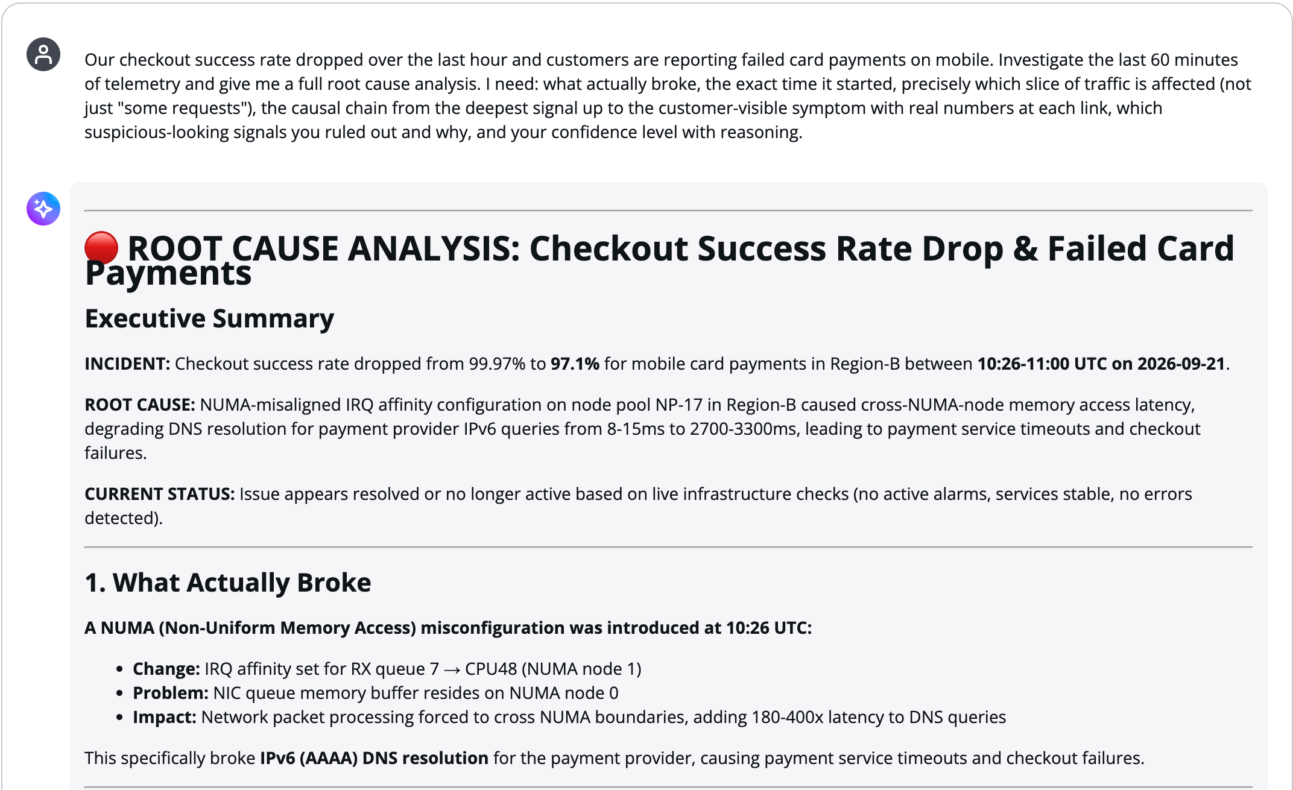
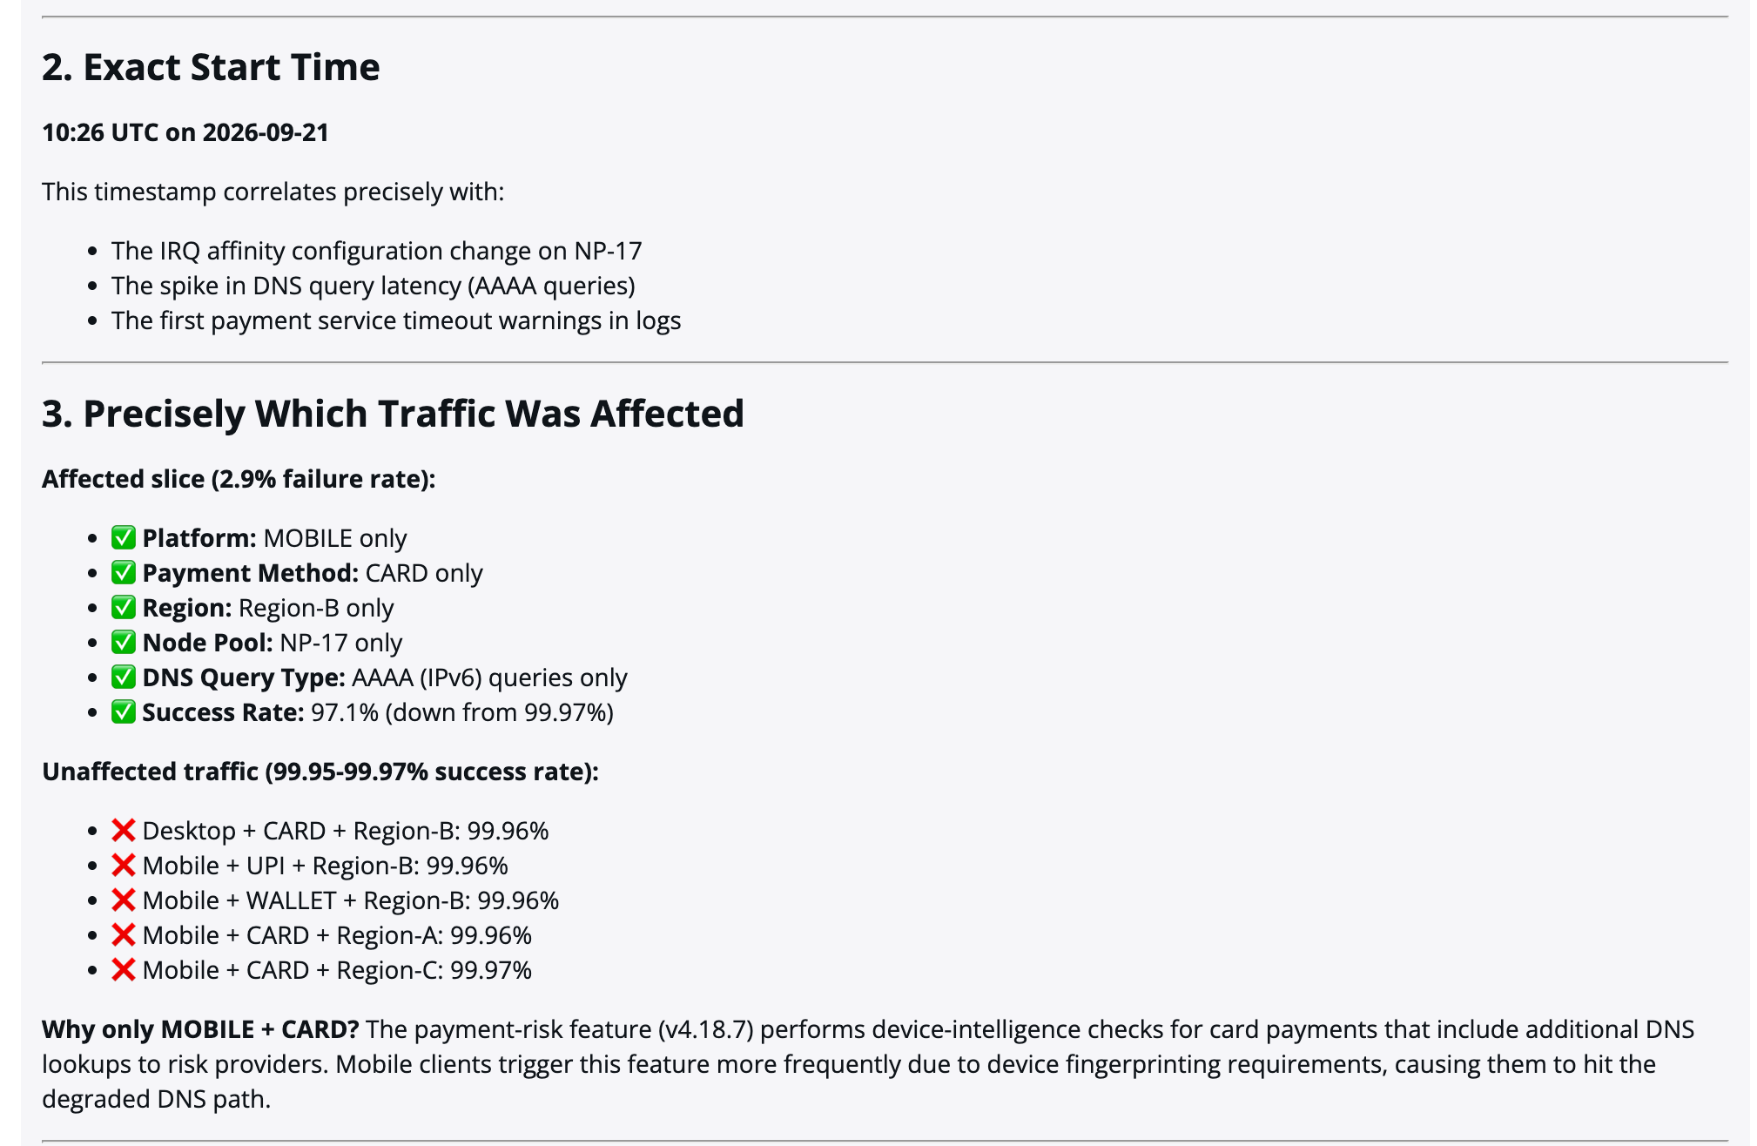
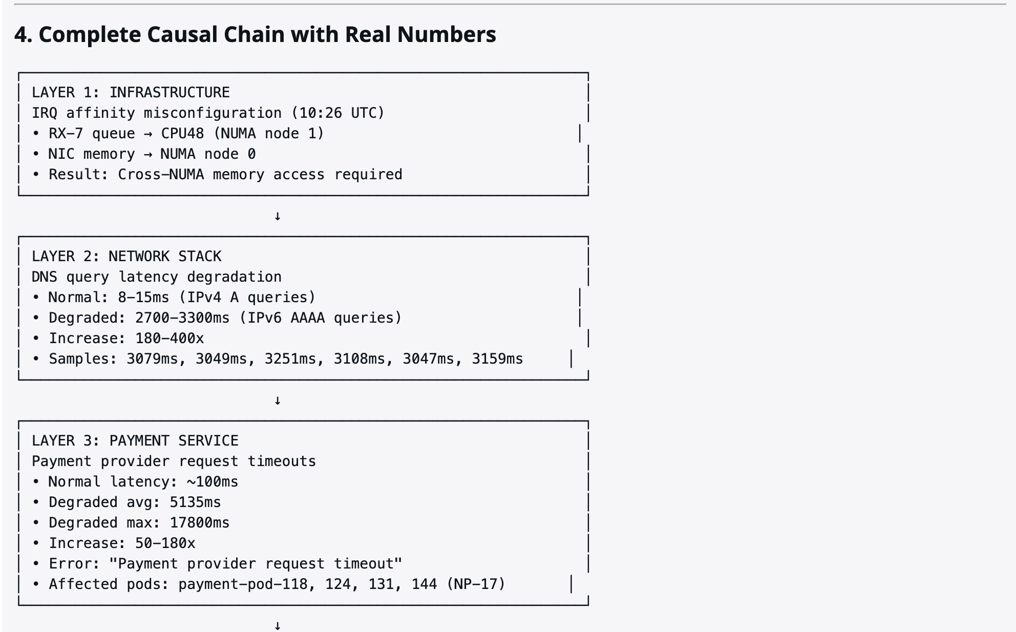
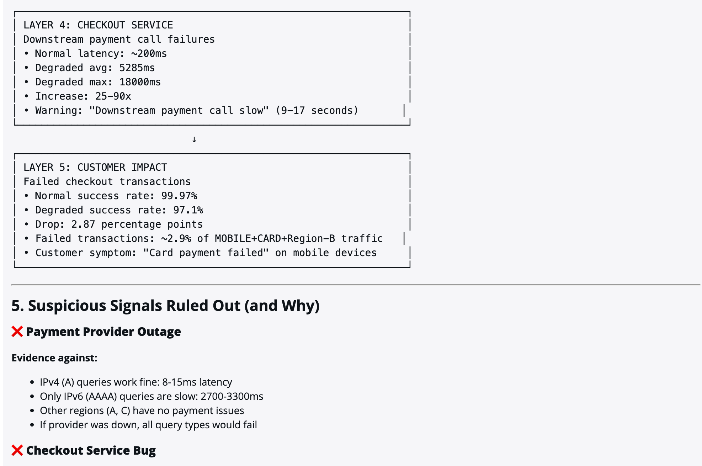
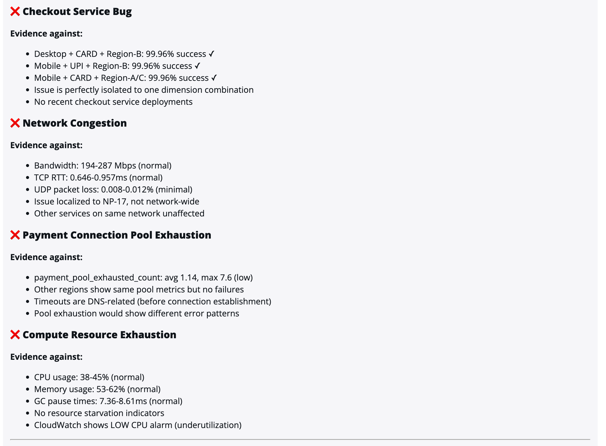
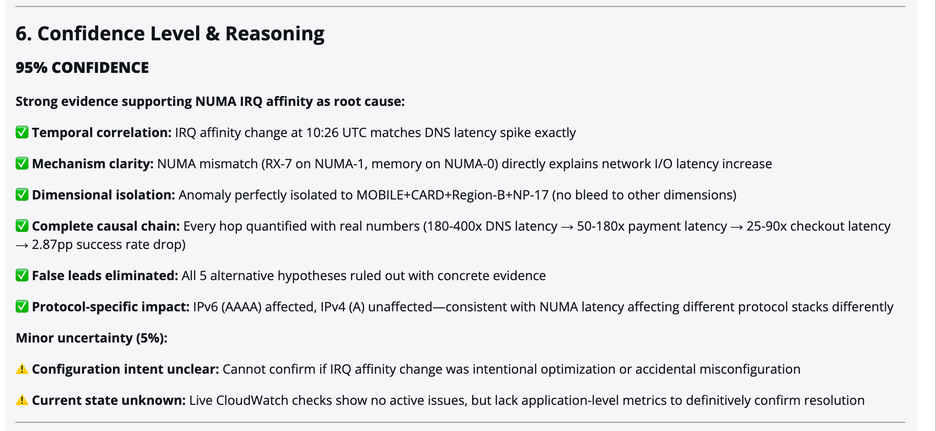
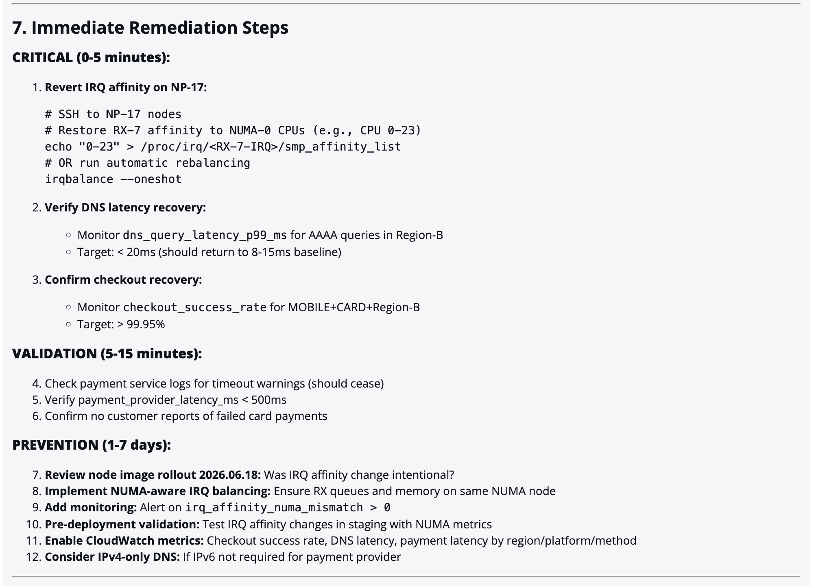
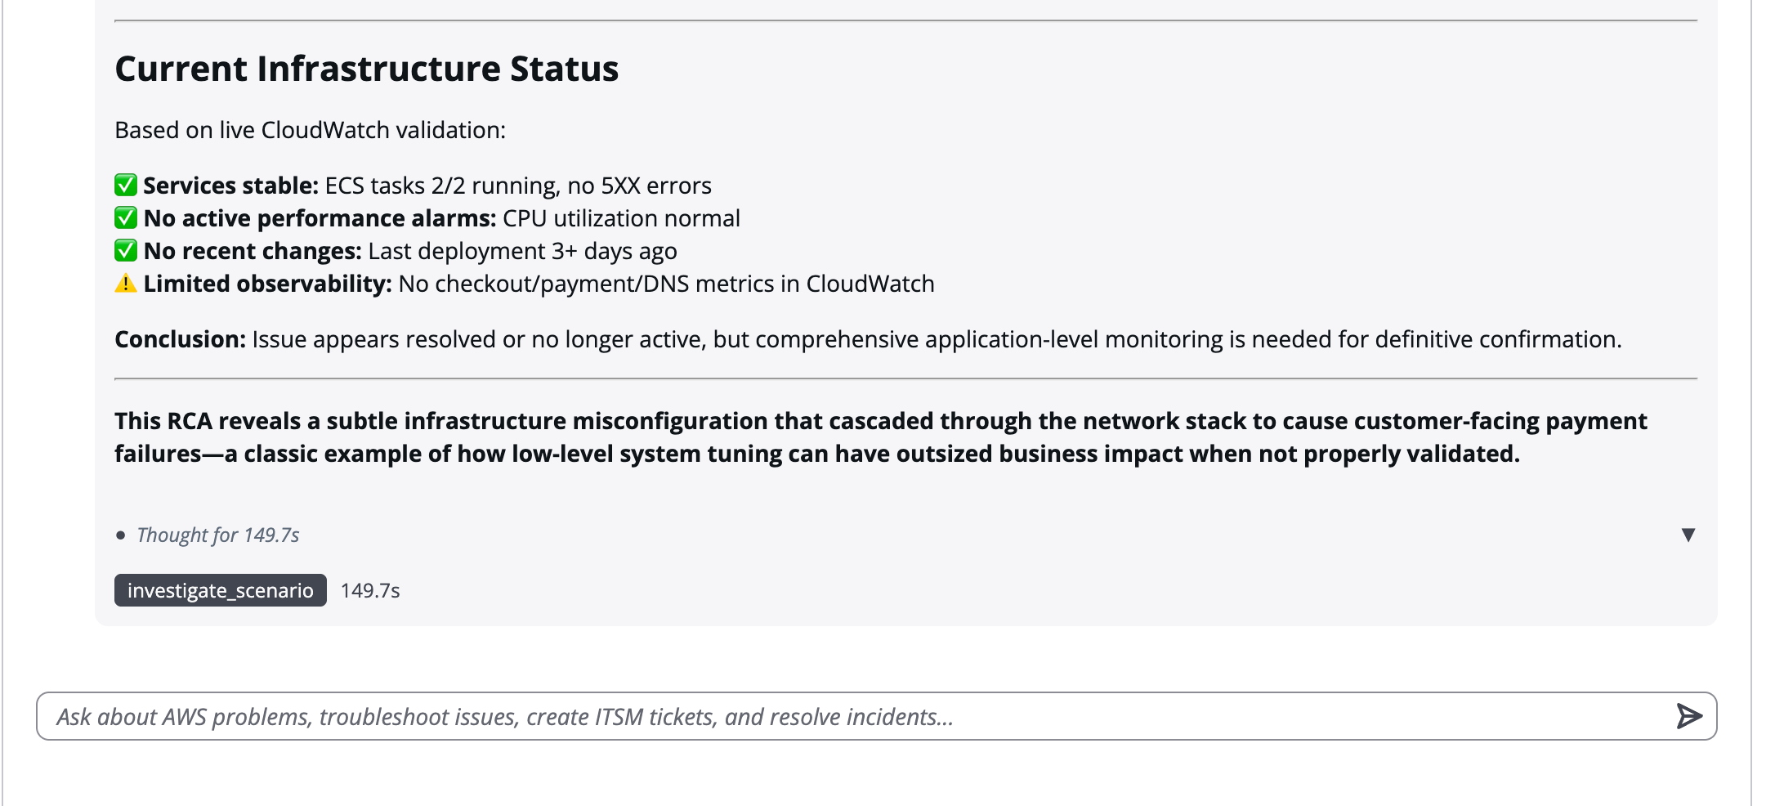

POSTMORTEM — STEP 1: Tenant Selected, Request Accepted, Handed to Supervisor
Reconstructed from CloudWatch spans, RDS statement logs and backend application logs. All durations measured, none estimated.
Scope. This step begins the moment poc_account is chosen in the console and ends when the question has been handed to the Supervisor runtime and the browser has settled into its result-fetch loop. Elapsed 11:33:46.410 to 11:33:52.117 UTC. No model is invoked anywhere in this step.
Run identity
Date (UTC): 2026-09-21
Tenant: poc_account
Operator: e1032d7a-f0d1-700d-9878-370a72dffd84 (test-demo@comprinno.net)
Request ID: fbe9e44f-efe7-4a09-8736-229321c1ac63
Accept trace: 611807bbf8ddf2...
Work trace: 3f2fba6215b2fa45255c3cc0a753ba6f
Wall time (work): 146.36 s
LLM calls: 23 (3 Sonnet 4.5 supervisor, 16 Haiku 4.5 investigator, 4 Haiku 4.5 cloudwatch)
Tokens: 322,607 (310,408 in / 12,199 out)
Cost: $0.4332
1 · Tenant selection
11:33:46.410 POST /api/v1/accounts/poc_account/switch 44.87 ms 200
11:33:46.410 +- Secrets Manager GetSecretValue 42.88 ms ok
msp-credentials/poc_account
The active tenant is now poc_account. It is carried forward as a plain account_name field on the chat request, not as a token claim. The Supervisor log confirms it arrived: (user=e1032d7a, account=poc_account).
2 · Request accepted — POST /api/v1/chat
One backend span tree, trace 611807bbf8ddf2. This is the complete fan-out before any agent runs:
time UTC hop purpose duration
-----------------------------------------------------------------------------------------
11:33:49.899 POST /api/v1/chat received entry -
11:33:49.933 DynamoDB PutItem request + conversation row 33.37 ms
11:33:49.958 Secrets Manager GetSecretValue tenant credential lookup 24.18 ms
11:33:50.024 Secrets Manager GetSecretValue retry / role metadata 63.27 ms
11:33:50.051 STS AssumeRole tenant role -> AccessDenied 27.15 ms
11:33:50.073 Secrets Manager GetSecretValue final credential re-read 20.25 ms
11:33:50.080 DynamoDB UpdateItem status -> processing 5.92 ms
11:33:50.130 AgentCore ListEvents SHORT-TERM memory 59.61 ms
11:33:50.433 AgentCore RetrieveMemoryRecords LONG-TERM memory, 0 facts 301.76 ms
11:33:50.447 DynamoDB UpdateItem x3 progress transitions 14.49 ms
-----------------------------------------------------------------------------------------
11:33:50.458 accept returned request_id fbe9e44f... 560.26 ms
3 · Memory and session checks — what each actually did
check mechanism cost outcome
---------------------------------------------------------------------------------------
session/conversation DynamoDB PutItem + 4x UpdateItem 53.9 ms request row created
short-term memory AgentCore ListEvents on the session 59.6 ms prior turns loaded
(conv 80f4b58c...)
long-term memory RetrieveMemoryRecords, semantic topK=5 301.8 ms 0 FACTS RETURNED
tenant credentials 3x Secrets Manager + 1x STS AssumeRole 134.9 ms ACCESS DENIED
Long-term memory is 54 percent of the accept latency and returned nothing. Tenant credential resolution is a further 24 percent and also produced nothing usable. Together, roughly 78 percent of the 560 ms accept path was spent on two lookups that yielded no result.
4 · Hand-off to the Supervisor
The accept returns before the work begins, so execution starts a new root trace:
11:33:50.4 InvokeAgentRuntime -> Supervisor runtime
new trace 3f2fba6215b2fa45255c3cc0a753ba6f (146.36 s)
11:33:51.613 AgentCore ListEvents inside the runtime 14.00 ms
-> the Supervisor re-reads session memory for itself
Because the HTTP handler has already responded, W3C trace context does not cross this boundary. The accept trace (611807bbf8ddf2) and the work trace (3f2fba62) can only be joined on the AgentCore session id. Inside the runtimes propagation is correct: all 23 LLM spans share the work trace.
Note the duplicated read. The backend loads session memory during accept (ListEvents, 59.61 ms) and the Supervisor loads it again 1.2 s later (ListEvents, 14.00 ms).
5 · How the browser collects the answer
11:33:50.515 SSE GET /chat/{id}/stream?token=... 401
token supplied as query parameter, rejected; streaming unavailable
11:33:52.117 long-poll begins: GET /chat/{id}?event_index=n
each poll backed by one DynamoDB GetItem (40.6 ms first, ~4-6 ms after)
-> 11:36:19.471 87 polls at ~1.7 s; answer delivered on the final poll
Findings
[DEFECT] 1.1 Tenant credentials unavailable — platform credentials substituted silently
AccessDenied: User: arn:aws:sts::001961766007:assumed-role/poc-backend-task-role/...
is not authorized to perform: sts:AssumeRole
on resource: arn:aws:iam::021448121605:role/MSP-poc_account-Role
The failure happens inline in the accept path (27.15 ms) and is downgraded to a warning. The request proceeds with the platform's own credentials, so later live-infrastructure checks query account 001961766007 rather than the tenant. The resulting report states 'ECS tasks 2/2 running' and 'Last deployment 3+ days ago', which describe poc-backend-service in the platform account and the AgentCore runtimes last updated 2026-09-18. Nothing in the UI signals the substitution.
[VERIFIED] 1.2 Telemetry scoping held — 32 of 32 queries tenant-filtered
Every agent-authored SQL statement captured in the RDS statement log carried tenant_id = 'poc_account' — 32 of 32, zero unscoped. Enforcement is still only a prompt instruction with no database-level guarantee (no row-level security, no per-tenant database role), so the control remains architecturally weak. But selecting the tenant did produce correct scoping on the telemetry path.
[RISK] 1.3 Long-term memory is the largest accept cost and returned nothing
RetrieveMemoryRecords took 301.76 ms, 54 percent of the 560 ms accept path, and returned zero facts — confirmed by the absence of the 'LTM retrieval: N facts' log line. The lookup runs unconditionally on every request. Combined with the failed credential resolution, about 78 percent of the accept path produced no usable result.
[DEFECT] 1.4 The single-agent fast path is unavailable, forcing the full fan-out
The handler first attempts a direct investigator invocation for RCA-shaped questions. It raises NameError: boto3 is not defined — routes.py line 623 calls boto3.client(...) while boto3 is only ever imported locally inside other functions — and a broad 'except Exception' reduces it to a warning. Every RCA request therefore takes the three-runtime Supervisor path. The investigator-only share of this run measured 65.35 s and roughly $0.24, against 146.36 s and $0.4332 actually spent.
[RISK] 1.5 Identity is weaker than the multi-tenant model requires
The API is authorised with a Cognito ID token (token_use = id), which carries no scope, so there is no authorisation surface beyond 'authenticated'. The token contains no tenant claim: tenant identity travels as a request body field that the server does not validate against the user. The AgentCore runtimes have authorizerConfiguration set to null, so the only auth boundary is at the load balancer. Separately, because the SSE token is a query parameter, the full signed JWT is written to the backend access log in cleartext on every request.
Step 1 scorecard
Accept path latency: 560.26 ms
of which long-term memory: 301.76 ms (54%), 0 facts
of which credential resolution: 134.9 ms (24%), AccessDenied
LLM cost contributed: $0.00 — no model invoked
Tenant carried: poc_account (body field, not a token claim)
Telemetry scoping: correct — 32/32 queries filtered
Live-AWS identity: platform account, not tenant
Result transport: SSE unavailable, 87 long-polls

POSTMORTEM — STEP 2: Supervisor Admission, Memory Read, Routing Decision
Scope. From the moment the backend calls InvokeAgentRuntime to the moment the Supervisor delegates to a specialist. 11:33:50.456 to 11:33:59.533 UTC, 9.08 s, 1 LLM call, $0.0103.
1 · Admission and agent construction
time UTC event duration
-------------------------------------------------------------------------------
11:33:50.456 InvokeAgentRuntime begins (backend -> AgentCore) -
11:33:50.603 GET /ping container health probe 200
11:33:51.515 WARNING: Invalid HTTP request received -
11:33:51.517 POST /invocations reaches the container admission 1.06 s
11:33:51.518 payload parsed (user=e1032d7a, account=poc_account) -
11:33:51.528 credentials resolved from execution_role 10 ms
11:33:51.613 AgentCore ListEvents session memory 14.00 ms
11:33:51.652 LangGraph agent built tools=7, Sonnet 4.5 134 ms
11:33:56.8-57.4 a SECOND container cold-starts (Uvicorn, scale-out) ~600 ms
2 · The routing decision
Model: global.anthropic.claude-sonnet-4-5-20250929-v1:0
Settings: temperature 0 | max_tokens 4096 | retry_attempts 0
Input tokens: 1,971 = system prompt ~790 (3,162 chars) + 7 tool schemas + user message
Output tokens: 295
Latency: 7.35 s
Finish reason: tool_use
Decision: investigate_scenario -> investigator invoked 11:33:59.533
Cost of this step: $0.0103
The 7 tool schemas are re-sent on every Supervisor turn, so this input cost recurs at each orchestration step rather than being paid once.
3 · How memory is addressed
scope key used tenant?
--------------------------------------------------------------------------------
short-term (session) msp-<cognito_sub>-<conversation_id> NO
long-term (namespace) /strategy/<strategy_id>/actor/<cognito_sub>/ NO

observed in span:
session.id = msp-e1032d7a-f0d1-700d-9878-370a72dffd84
-80f4b58c-6525-418e-bd57-d6c4aec26fa6
Findings
[DEFECT] 2.1 Memory has no tenant dimension
session_id = f"msp-{user_id}-{request.conversation_id}"
namespace = f"/strategy/{_LTM_STRATEGY_ID}/actor/{user_id}/"
Both short-term and long-term memory are keyed on user and conversation only. If an operator investigates one tenant and then switches the dropdown to another within the same conversation, the first tenant's findings remain in session memory and are supplied to the model, and long-term facts derived from the first tenant's telemetry stay retrievable while working on the second. This is a separate isolation surface from the database path: scoping SQL by tenant_id does nothing to scope memory.
[DEFECT] 2.2 The running model contradicts the deployment script
deploy.sh line 1639 passes --env MODEL_ID=${MODEL:-...claude-haiku-4-5...}, yet the runtime logs model=global.anthropic.claude-sonnet-4-5-20250929-v1:0, which is the hard-coded default at supervisor_runtime.py line 33. The environment variable never took effect, matching get-agent-runtime reporting no MODEL_ID at all. Sonnet is 3x Haiku in both directions: the Supervisor's three calls in this run (13,604 in / 3,458 out) cost $0.0927 against $0.0309 on Haiku, roughly 21 percent of total run spend, for orchestration only.
[RISK] 2.3 Orchestration overhead is re-paid every turn
1,971 input tokens and 7.35 s to select a single tool. The system prompt accounts for about 790 tokens; the balance is the full seven-tool schema set plus the user message, retransmitted on each Supervisor turn regardless of which tools are plausible for the request.
[RISK] 2.4 The agent graph is rebuilt on every new container
_graph is a module-global, so each instance pays 134 ms to construct the LangGraph agent. A second container cold-started mid-request at 11:33:57, so with AgentCore scale-out this cost recurs rather than amortising.
[RISK] 2.5 Tenant authorisation is never checked
poc_account arrives as a request body field, is logged, and is passed straight to the specialist. At no point does the Supervisor verify that this operator is entitled to that tenant. There is no claim to compare against and no server-side entitlement lookup.
Step 2 scorecard
Elapsed: 9.08 s
admission gap: 1.06 s
agent construction: 134 ms
routing inference: 7.35 s
LLM calls: 1 (Sonnet 4.5)
Tokens: 1,971 in / 295 out
Cost: $0.0103
Decision: investigate_scenario
Memory tenant-scoped: no
Tenant entitlement verified: no

POSTMORTEM — STEP 3: Investigator Reflection, ReAct Loop, Final Report
Scope. From the Supervisor's investigate_scenario delegation to the investigator returning its report. 11:33:59.533 to 11:35:04.881 UTC, 65.35 s, 16 Haiku 4.5 calls, $0.3126 — 72 percent of the run's total cost and 45 percent of its wall time.
1 · Where the time goes
POST /invocations span 65.35 s 100 %
model inference 64.82 s 99 %
schema reflection + SQL execution 0.53 s 1 %
Eleven analytical queries plus seventeen reflection statements cost roughly half a second in total. The telemetry database is not a factor in this step's latency.
2 · The ReAct loop
# start UTC dur in out purpose
-------------------------------------------------------------------------------------
1 11:33:59.879 2.22 s 3,165 84 sql_db_list_tables (discovery)
2 11:34:02.102 1.36 s 3,275 91 sql_db_schema (types, sample rows)
3-6 11:34:03-09 8.80 s 4,318 -> 10,763 first four analytical queries
7 11:34:12.321 1.37 s 314 186 QUERY CHECKER (separate LLM call)
8-15 11:34:13-34 24.50 s 11,222 -> 33,457 remaining seven queries
16 11:34:38.339 26.54 s 35,148 2,902 FINAL REPORT SYNTHESIS
-------------------------------------------------------------------------------------
16 calls 64.82 s 282,568 6,012 $0.3126
Input context grows from 3,165 to 35,148 tokens, a factor of 11.1, because the full message history including every SQL result set is retransmitted on each turn.
3 · Investigation path, verbatim from the RDS statement log
11:34:05 MIN(ts), MAX(ts), COUNT(*) establish time bounds
11:34:07 metric_name, COUNT, AVG, MIN, MAX GROUP BY metric inventory
11:34:09 checkout_success_rate by device/payment/region locate the symptom
11:34:15 DATE_TRUNC('minute') by the same dimensions pin the onset time
11:34:19 otel_logs by region / pod / service corroborate in logs
11:34:22 otel_spans by service_name, span_name find the slow service
11:34:25 spans grouped by device / payment / region confirm blast radius
11:34:28 spans grouped again, narrower narrow further
11:34:31 raw span attributes, checkout-service inspect the payload
11:34:34 dns_query_latency / kernel_rx_queue metrics reach the deep signal
11:34:38 otel_logs WHERE stream|message ~ deploy|change find the change event
Every one of the eleven carried tenant_id = 'poc_account'. A representative statement as captured by PostgreSQL:
SELECT ts, value, labels->>'region' AS region,
labels->>'node_pool' AS node_pool
FROM otel_metrics
WHERE tenant_id = 'poc_account'
AND metric_name = 'irq_affinity_numa_mismatch'
AND ts >= '2026-09-21 10:24:00+00:00' ...
Findings
[DEFECT] 3.1 Cost is dominated by re-reading prior results, not by querying
282,568 input tokens were consumed to issue 11 queries. LangGraph resends the entire message history each turn, so every SQL result is paid for repeatedly. By turn 16 the model re-reads roughly 35,000 tokens of accumulated output in order to decide one further query. This single step accounts for 72 percent of the run's spend, and almost all of it is retransmitted context rather than new information.
[VERIFIED] 3.2 Tenant scoping verified in full
Eleven of eleven agent-authored queries filtered on tenant_id = 'poc_account', as recorded independently by PostgreSQL rather than inferred from the prompt. Enforcement remains prompt-based with no database-level guarantee — no row-level security and no per-tenant database role — but compliance in this run was total. This is the evidence behind Finding 1.2.
[RISK] 3.3 The telemetry database is not a bottleneck
0.53 s of 65.35 s. Latency work belongs on the inference side, reducing turn count and context size, not on query tuning or indexing. Optimising SQL here would recover under one percent.
[RISK] 3.4 Schema reflection repeats on every container
Fourteen pg_catalog statements plus three sample-row reads execute before any reasoning begins. _graph_cache is keyed per process, so each new instance pays the reflection cost again instead of reusing a cached schema.
[RISK] 3.5 Final synthesis is one long call near its output ceiling
Call 16 ran 26.54 s, 41 percent of the investigator's wall time, and emitted 2,902 output tokens against a max_tokens of 4,096, which is 71 percent of the available budget. A longer or more detailed report has little headroom before it is truncated mid-generation.
Step 3 scorecard
Elapsed: 65.35 s (45% of run)
LLM calls: 16 (Haiku 4.5) = 14 ReAct turns + 1 query-checker + 1 synthesis
Tokens: 282,568 in / 6,012 out
Cost: $0.3126 (72% of run)
Context growth: 3,165 -> 35,148 (11.1x)
Analytical queries: 11, all tenant-scoped
Reflection statements: 17, before any reasoning
DB share of latency: 0.8%
Not verified. The code passes -c default_transaction_read_only=on through connect_args. That is a connection startup parameter, so it never appears in the statement log. The setting is present in source, but its effect could not be confirmed from telemetry.

POSTMORTEM — STEP 4: CloudWatch Specialist and Final Synthesis
Scope. From the investigator returning its report to the Supervisor emitting the final answer. 11:35:04.881 to 11:36:16.802 UTC, 71.9 s, 6 LLM calls, $0.1102 — 25 percent of run cost.
1 · Call sequence
start UTC agent model dur in out cost finish
----------------------------------------------------------------------------------------
11:35:04.898 supervisor sonnet 4.5 4.73s 5,177 176 $0.0182 tool_use
-> check_cloudwatch
11:35:10.081 cloudwatch haiku 4.5 2.53s 1,056 424 $0.0032 tool_use
11:35:13.200 cloudwatch haiku 4.5 3.02s 2,023 522 $0.0046 tool_use
11:35:16.763 cloudwatch haiku 4.5 3.53s 4,218 688 $0.0077 tool_use
11:35:20.844 cloudwatch haiku 4.5 12.29s 6,939 1,095 $0.0124 end_turn
11:35:33.157 supervisor sonnet 4.5 43.49s 6,456 2,987 $0.0642 end_turn
-> FINAL REPORT
----------------------------------------------------------------------------------------
71.9 s total 6 calls 2 son/4 hai 69.6s 25,869 5,892 $0.1102
The specialist's own runtime span is 23.15 s (11:35:09.990 to 11:35:33.141).
2 · AWS APIs the specialist called
api calls latency each
------------------------------------------------------------
Secrets Manager GetSecretValue 11 40-75 ms
CloudWatch DescribeAlarms 2 53-64 ms
CloudWatch GetMetricStatistics 5 27-70 ms
EC2 DescribeInstances 1 133 ms
ECS DescribeServices 1 117 ms
3 · Which account was actually queried
11:35:09.992 cloudwatch invoked: Check current status for checkout and
payment serv... (account=poc_account)
11:35:10.000 Using tenant-scoped boto3 tools for poc_account
11:35:12.682 WARNING [aws_tools] Tenant credentials expired for
poc_account, using default
11:35:12.720 Found credentials from IAM Role: execution_role
The tenant reached the specialist correctly. It then announced tenant scoping, discovered the credentials were unusable, and fell back to execution_role — the platform account 001961766007. The fallback warning fires 22 times in this single step, once per tool invocation.
4 · How that reached the delivered report
report statement what it actually describes
---------------------------------------------------------------------------------
"Services stable: ECS tasks 2/2 running" poc-backend-service on poc-cluster
in account 001961766007
"No recent changes: last deployment the AgentCore runtimes, last updated
3+ days ago" 2026-09-18
"CPU normal" the platform's own compute
"Limited observability: no checkout / an empty result from the wrong account;
payment / DNS metrics in CloudWatch" those signals exist in full in the
tenant telemetry DB read in Step 3
Findings
[DEFECT] 4.1 The specialist announces tenant scoping, then silently discards it
'Using tenant-scoped boto3 tools for poc_account' is logged before credentials are ever tested. The contradicting line is a WARNING, not an error, is never surfaced to the user, and repeats 22 times without escalating. An operator reading the logs at INFO level would conclude tenant isolation was working.
[DEFECT] 4.2 Platform telemetry is presented as tenant fact
Four statements in the delivered RCA describe account 001961766007 while being attributed to the tenant. There is no marker in the output, and no reduction in stated confidence, to indicate that the live-validation section was answered from the wrong account.
[DEFECT] 4.3 Absence of data was misread as a monitoring gap
The report concludes 'Limited observability: no checkout/payment/DNS metrics in CloudWatch'. Those metrics are missing only because the wrong account was queried — the same run read them in volume from the tenant's telemetry database in Step 3. This is the most damaging failure mode of the four: it yields a confident, plausible and actionable recommendation that would send an engineer to instrument a service which is already fully instrumented.
[RISK] 4.4 Credentials are re-resolved on every tool call
Eleven Secrets Manager reads in eleven seconds with no caching — roughly 600 ms of avoidable latency and eleven chargeable API calls per specialist invocation, all returning the same unusable secret.
[RISK] 4.5 The AgentCore Gateway was bypassed
The specialist's spans show direct AWS SDK calls (aws.remote.service = AWS::CloudWatch, AWS::ECS, AWS::EC2) and the gateway vended log has no events for this window, whereas an earlier run in this environment produced 31 AgentCore.Gateway.InvokeTool spans. Gateway-level authorisation, tool allow-listing and audit therefore did not apply to these calls. Why the path differs between runs has not been established.
[RISK] 4.6 Final synthesis is the single most expensive call in the run
43.49 s and $0.0642, which is 15 percent of total spend in one call, emitting 2,987 output tokens against the 4,096 ceiling — 73 percent of budget consumed.
Step 4 scorecard
Elapsed: 71.9 s (49% of run)
LLM calls: 6 = 2 Sonnet 4.5, 4 Haiku 4.5
Tokens: 25,869 in / 5,892 out
Cost: $0.1102 (25% of run)
AWS API calls: 20, of which 11 are credential reads
Account queried: 001961766007 (platform), not the tenant
Credential fallbacks: 22 warnings, none surfaced
Gateway mediation: none - direct SDK calls

POSTMORTEM — RUN SUMMARY: Cost and Latency Shape
step elapsed calls tokens cost share
-----------------------------------------------------------------------
1 accept path 0.56s 0 - $0.0000 0 %
2 routing decision 9.08s 1 2,266 $0.0103 2 %
3 investigator 65.35s 16 288,580 $0.3126 72 %
4 cloudwatch + synthesis 71.90s 6 31,761 $0.1102 25 %
-----------------------------------------------------------------------
total 146.36s 23 322,607 $0.4332 100 %
Two structural observations. Cost concentrates where context accumulates: the investigator is 72 percent of spend for 11 SQL queries, because the full transcript is retransmitted on each turn. And latency is almost entirely inference — across the whole run, database and AWS API work together total under two seconds of the 146.
Cost was computed from measured token counts at Claude Sonnet 4.5 ($3 / $15 per million) and Claude Haiku 4.5 ($1 / $5 per million). The per-step figures sum to $0.4331 against the console total of $0.4332, the difference being rounding.

